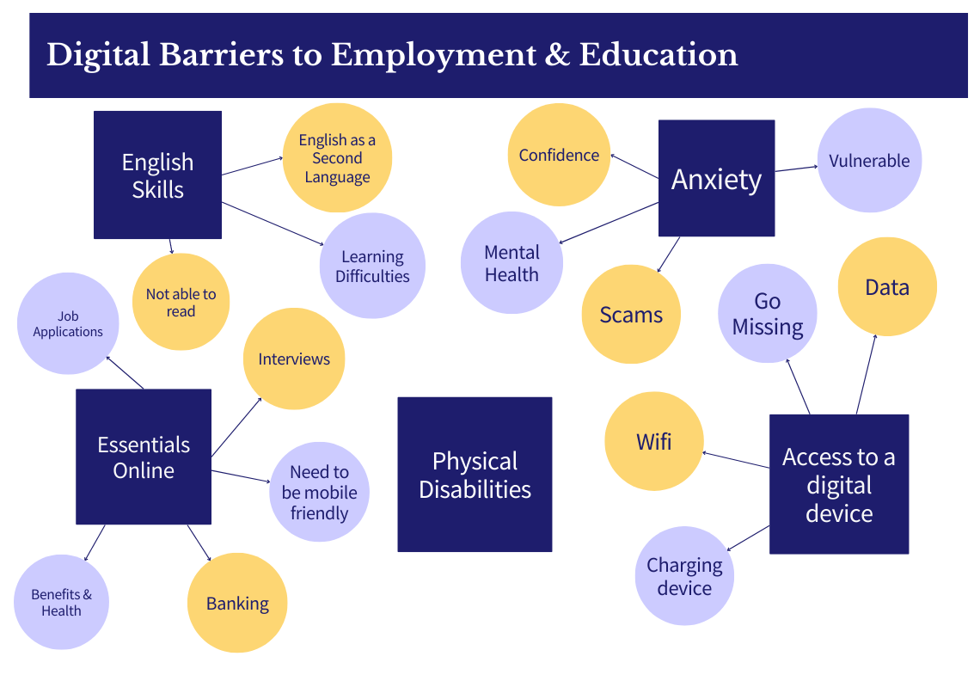
ACTIONS TO TAKE FORWARD
Digital skills workshops
Devices and data
Employer understanding
User experience defined by clients
Application support workshops
Physical (paper based) applications
Training
Recruitment days / workshops

POSSIBLE RESOLUTIONS
Training health professionals
Simple user friendly with no jargon
Use of technology face to face – a person to bridge the gap or hold a hand
Peer support from people with lived experience
Strengths based and person centred
Communication with software developers
Need to raise questions of who are using which apps, are they fit for purpose
Opportunities to print a form and upload it

ISSUES IDENTIFIED
GP Registrations – appointments and scripts
Bank Accounts – for access to wages
Managing debt
Poorly designed UI/UX – poor accessibility can lead people to give up, negative experiences can put people off for a long time
Age as a factor – different experiences and different operating systems
Smart phone access in TA is basic
Lacking confidence and skills
Important to get people interested and see the value in tech
Fear around using technology – digital misinformation or paranoia
Non-English speakers, illiteracy, and neurodiversity
Accessing forms of ID – birth certificates, utility bills etc.
Cashless society – relying on contactless payments and digital apps
Accessing universal credit

