About the GM Homelessness Action Network
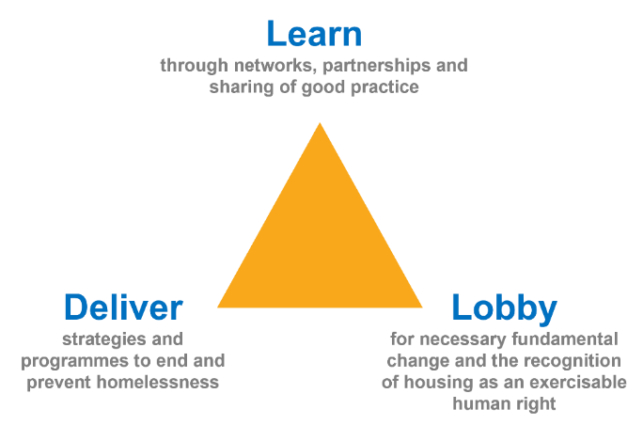
The Greater Manchester Homeless Action Network (GMHAN) is a collaboration of everyone working to the mission of ending and preventing homelessness in Greater Manchester. It brings together all the different sectors, specialisms and experiences which are involved in achieving this mission, recognising that we can achieve more through collaboration and partnership
There are three functions which the Network focuses on to help us reach our goal:

What are Task Groups?
Task Groups are part of the Co-ordination of the GM Homelessness Action Network, helping deliver its mission by:

- Focusing on a specific purpose of the HAN (e.g. Learning; Lobbying; Delivery)
- Lead on directing and galvanizing activity around that purpose
- Propose their own short-term objectives to make progress toward it
- Report back into the Co-ordination Group and wider network to involve others in emerging pieces of work and minimise duplication of effort
- Put forward topics for Open Space sessions and items at Full Network Events

Tasks Groups are expected to meet monthly with ongoing communication between members around actions. They will be supported by any paid, dedicated resource available to the Network but retain ultimate responsibility for delivering their objectives. They will be reviewed yearly, with opportunity to rotate positions. Estimated time commitment for a normal member is 3-5 hours/month (2hour meeting, with extra for actions).
Task Group Chairs will also be members of the overarching Co-ordination Group, which will have an additional 2 hours meeting every other month. For more information on the structure and roles of the HAN, see the Terms of Reference.
Expenses & Participation
In keeping with wider Greater Manchester commitments to equality, the HAN wants to provide fair compensation via participation expenses for anyone joining these groups who is unwaged.
Participation expenses will paid for all meetings and preparation (30mins/hour of meeting) at:
- £20 per hour flat rate
- Paid directly to the individual on a monthly basis
For a normal task group member, this would be estimated as £60 for a 2 hour meeting plus 1 hour prep.
If you are in receipt of State Benefits please check if this would affect your entitlement.

Expression of Interest
Please answer these simple questions below if you would like to be part of the Co-ordination Group or a Task Group. Only brief details are asked for at this point, with opportunities later on to answer any questions or make additional arrangements required.
For any queries and to submit your expression of interest, email info@gmhan.net.
Which Task Group would you like to be involved with?
Learning Task Group  ☐ | Lobbying Task group  ☐ |  | Delivery Task Group  ☐
What role on the group would you like to put yourself forward for?
Co-Chair  ☐ |  | Member  ☐

Name
Role and Organisation (if relevant)
Contact email address
Contact phone number
What motivates you personally to get involved with this Task Group?

(This could be personal experience, professional connection, social purpose or anything that drives you)

What do you feel like you are good at which might be relevant to this Task Group?

(This could be anything from your professional or personal life, and will help to build a varied and effective team)

Are there any other activities, programmes or initiatives you are or have been involved with that are relevant to this Task Group?

(This includes the HAN itself, as well as things like local borough partnerships, one-off activities or events, or services/programmes connected to homelessness)

Are there any restrictions on when you are available? Is there anything we can do to help you meet the time commitment outlined on the first page?

